Implement the All UAT Points

Contents
Testing Completed By 1
All UAT Points- 1
Login Page- 1
Dashboard 2
1. Top 10 2
Contact List 4
Sales Quote 4
Warehouse 5
Business Plan 7

Testing Completed By
Project Name | Developer Testing By | Testing Reviewed By | Approved By
Prakash Chem Ag. Pvt Ltd | Praduman Kumar

All UAT Points-

Login Page-
- I have Login successfully for AK18 Salesperson User.
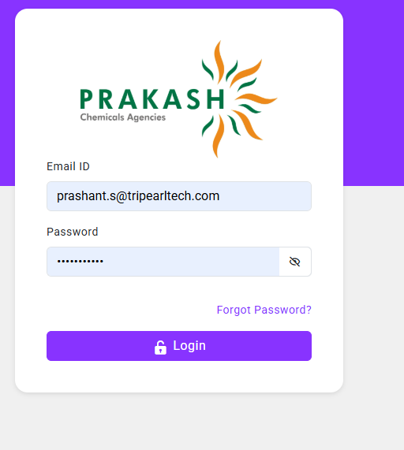

Dashboard
- Top 10 Customers to be shown like Top 10 products.
  - Check the dashboard page for target VS Sales.
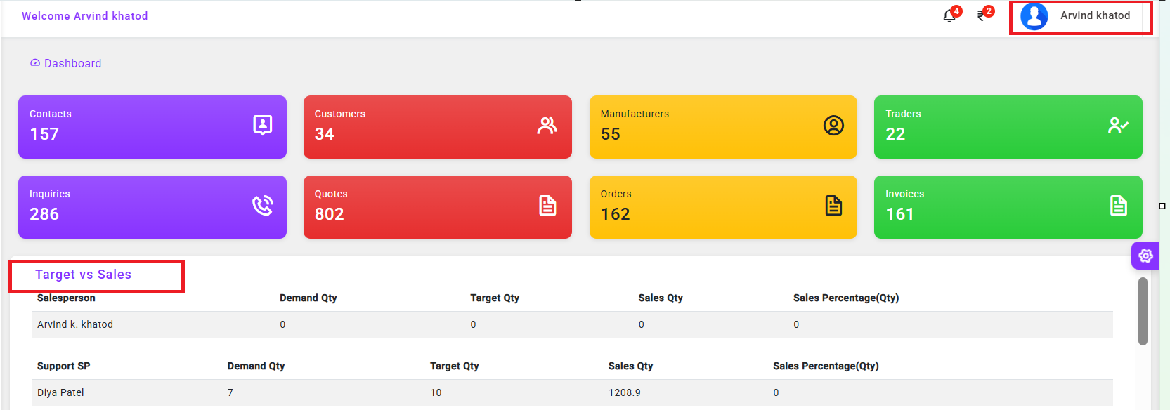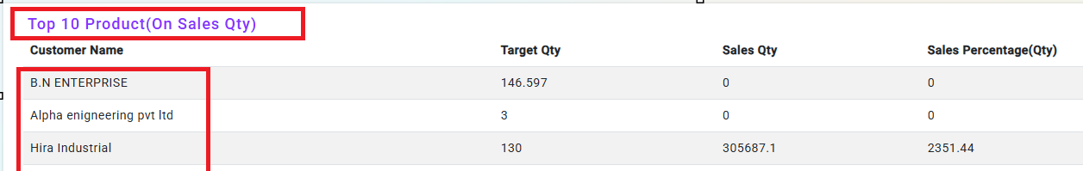

- In every section, provide Date filter. By default, today's date filter for dashboard.
  - Added the Daily Visit Model on the today date filter before adding the record. 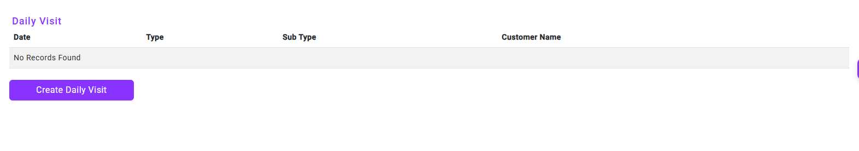
  - After adding the record on the today dat
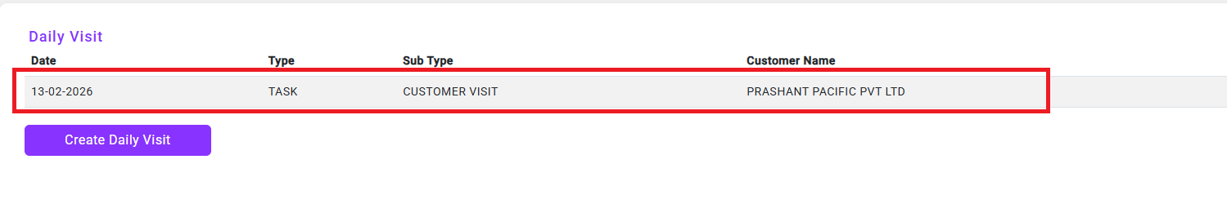
Provide "New" action for creating Daily Visit in Today's Task section - on click, redirect it to Daily Visit card.
- Added the New Action button
  - Daily Visit. 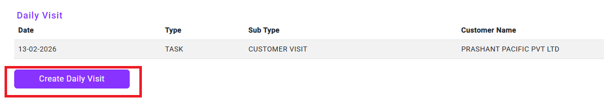
  - After clciking the create daily visit action redirect it to Daily Visit card. 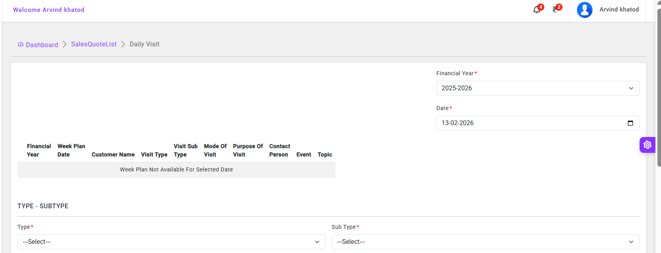

- Today, Task add the new action redirect the Daily Visit card 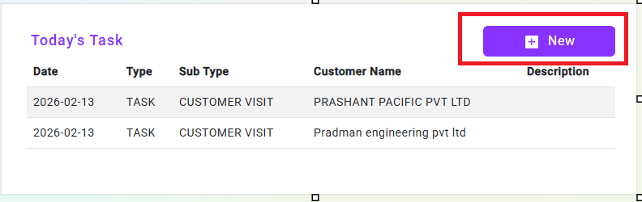
After clciking the create daily visit action redirect it to Daily Visit card.


- Dashboard of Salesperson with actual statistics shows - "Mayur" as static value even when the login is of another salesperson.
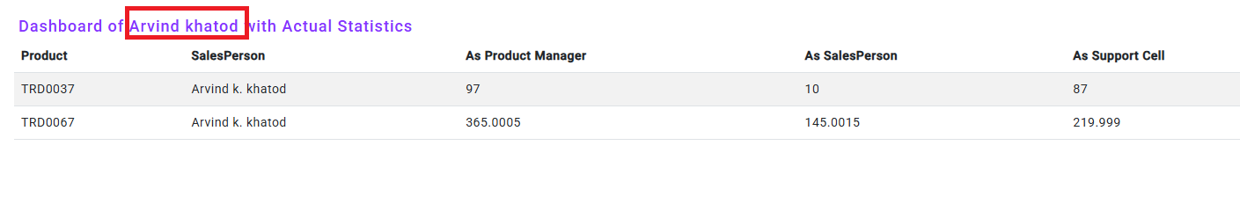
The issue has been resolved, and the system now displays the name of the logged-in salesperson

Contact List
- Provide "Company Name" filter option as default in Contact list.
- Select the Contact List menu and verify that ‘Company Name’ is the default filter option. 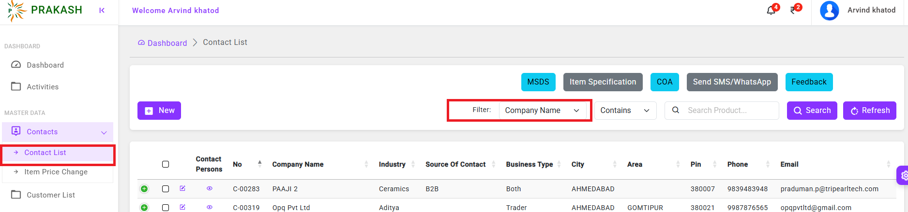

Sales Quote
- I have fixed this issue Payment Terms to be shown at header level only.
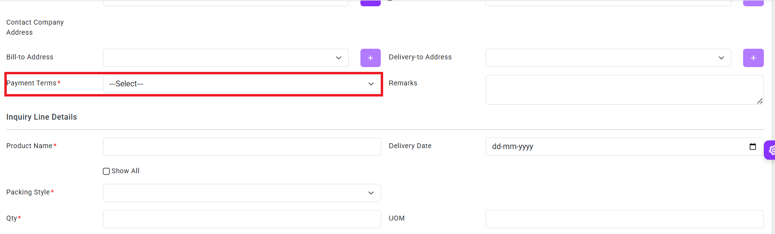
- Payment Terms to be shown at header level only. And, once the 1st product line inserted and saved, the fields of - Payment Terms, Inco Terms, and Transport Method should be locked [Editable = False].
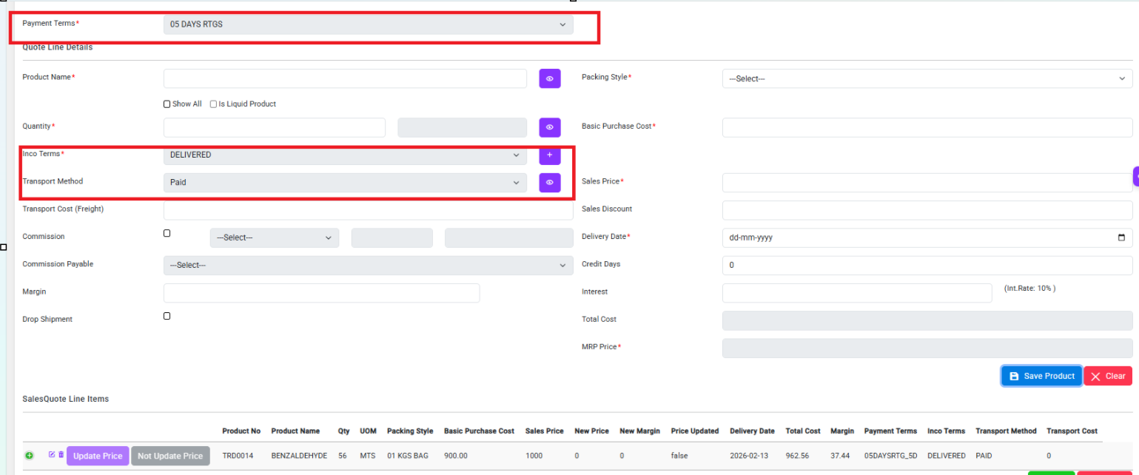
After saving a record, the Payment Terms, Inco Terms, and Transport Method fields will be disabled.

- In the partial case, the External Document No. should remain the same when scheduling for the second time in the same quote the Purchase Order Date (Document Date) should be displayed in the Schedule Order window beside the External Document No. field
Before Save the data. 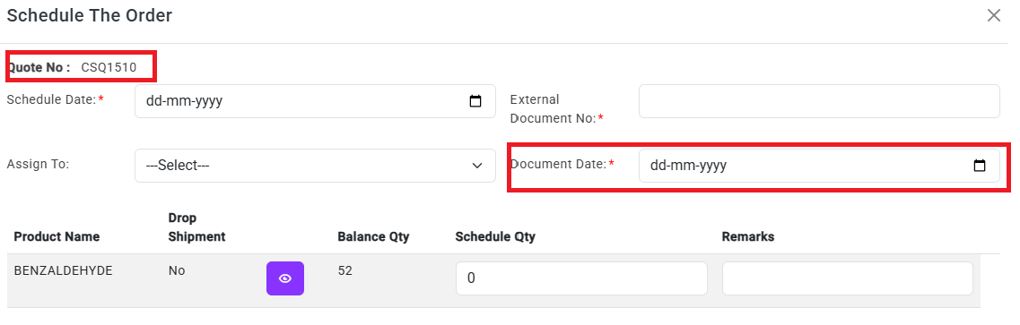
After Save the data. 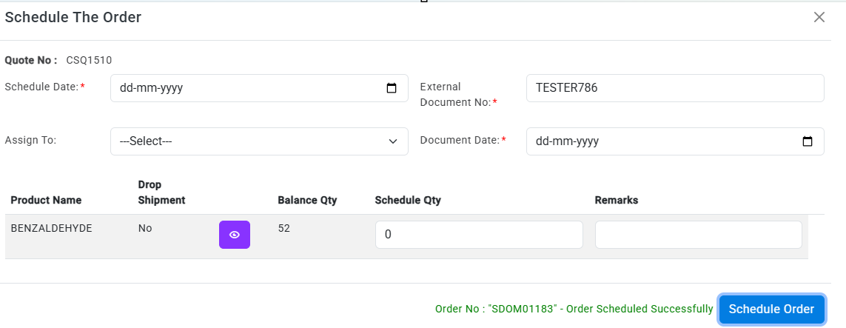

Warehouse
- Warehouse ongoing sorting and filter.
  - I have fixed the sorting functionality on the Ongoing and Closed Task List pages.
    - Click the Ongoing Task List menu in the Warehouse section.
    - Validate the all-column filter.
    - Validate the Filter section on the document type filter.
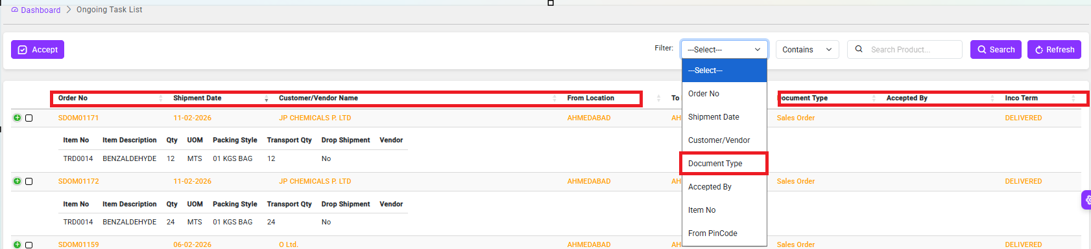

- Same implementation on Closed card list.
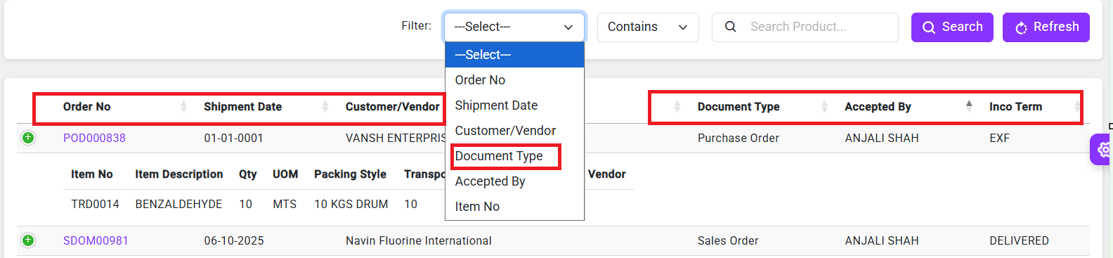.
- I have changed the Transporter No. field caption.
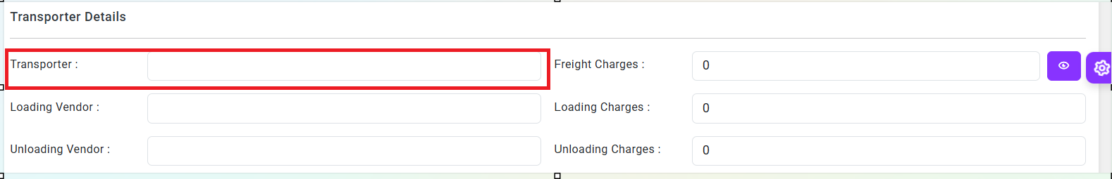

- I have fixed the Driver Mobile No. field value - validation of 10 characters required. 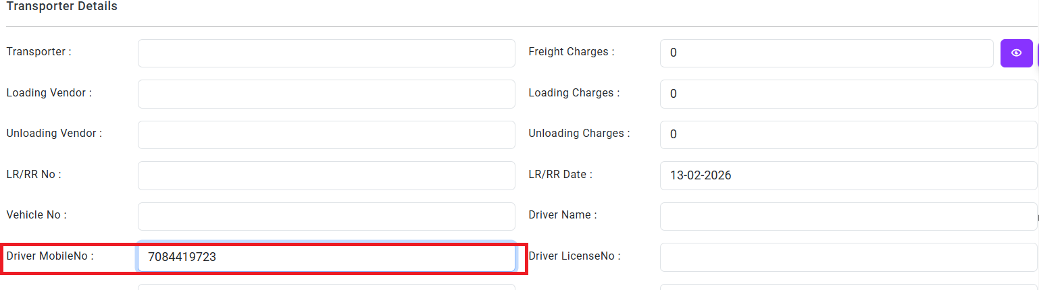
Driver mobile no. enter the field value max 10 digit only.
- Added an asterisk (*) to mark the Transporter No. and Vehicle No. fields as mandatory.
- Enabled wrap text in the Remarks field.
- Updated the caption in the Invoiced Qty. window — changed “Qty.” to “Qty. in MTS” and removed the UOM field. 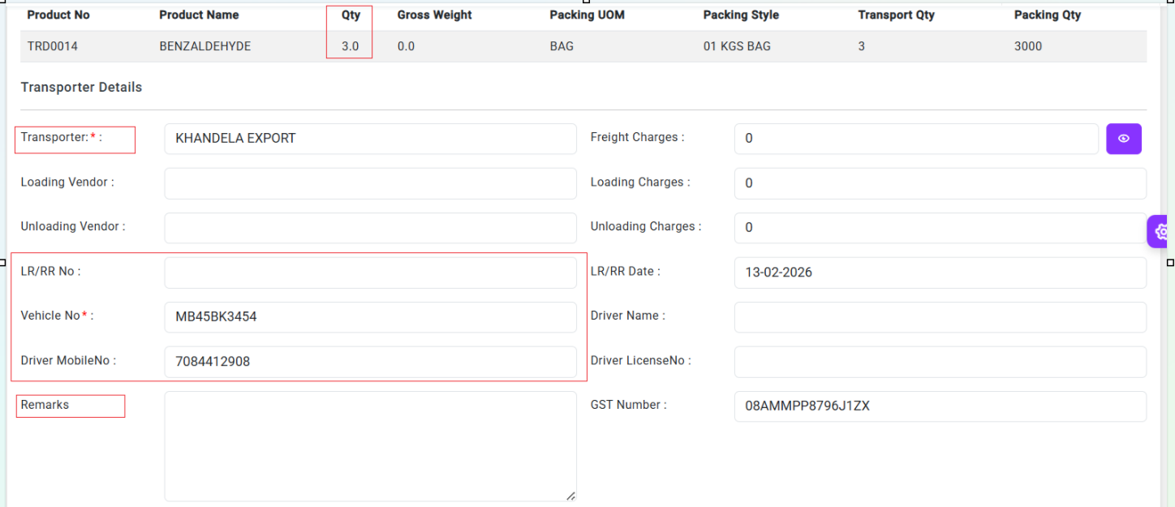

Business Plan
- I have fixed the Business Plan Report page related the filters.
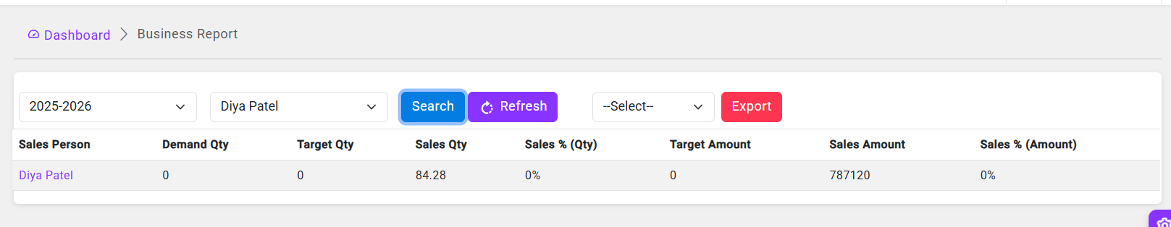
- In the Create Business Plan screen, the Cancel action has been changed to Close.
Now, on clicking Close, the user is redirected back to the previous page with the same filter (Filled, Not Filled, etc.) that was originally selected, instead of defaulting to the Not Filled filter page. 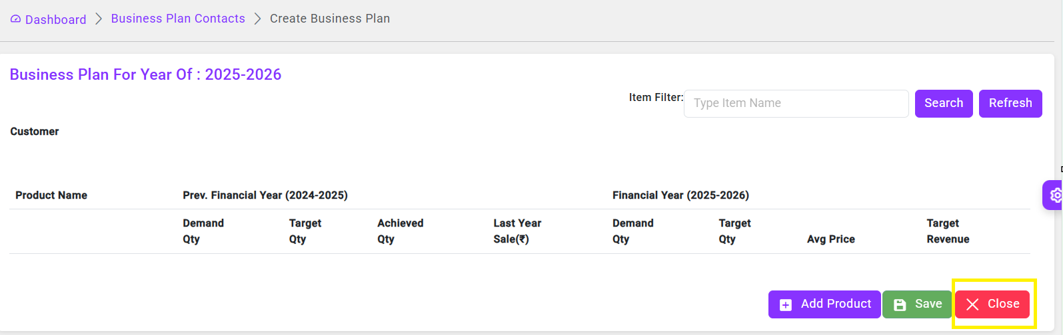

Thank You!

